**Difference between JSON and XML**

|  |  |  |
| --- | --- | --- |
|  | **JSON** | **XML** |
|  | **JSON : “JavaScript Object Notation”.** | **XML: “Extensible Markup Language”.** |
|  | JSON is extended from **JavaScript.** | XML is extended from **SGML** : “**Standard Generalized Markup Language**“. |
|  | JSON is one type of text-based format or standard for interchanging  data i.e.**human readable**. | XML is a **Markup Language** having format that contains set of rules for the encoding the documents which is readable for both **human & machine** |
|  | JSON syntax is lighter than XML as JSON has serialized format of data having  less redundancy. JSON does not contain start and end tags. | XML is not so lighter as JSON as having start and end tags and it takes more character than JSON to represent same data. |
|  | JSON is light – weighted in compare to XML as it has serialized format and so faster also. | XML is not so light weighted as JSON. |
|  | JSON supports **datatype** including integer and strings, JSON also supports array. | XML does not provide any data type so needs to be **parsed** into particular datatype. No direct support for array also. |
|  | JSON does not support **Comments** | XML supports comments. |
|  | JSON does not have support for Namespaces. | XML supports **Namespaces**. |
|  | JSON is **data oriented** and can be mapped more easily. | XML is **document oriented** and needs more effort for **mapping**. |
|  | For W**eb services**, JSON is better. | For **configuration**, XML is better. |
|  | You can not change JSON data to other **format**. | In XML, using **XSLT** you can change XML data into another format like **comma –delimited, plain text**, JSON, etc. |

### JSON

{

"company": Volkswagen,

"name": "Vento",

"price": 800000

}

### XML

<car>

<company>Volkswagen</company>

<name>Vento</name>

<price>800000</price>

</car>

# JSON :

* JSON stands for JavaScript Object Notation
* JSON is very light weight, structured, easy to parse and much human readable.
* JSON is best alternative to XML when your android app needs to interchange data with your server.
* Android provides support to parse the JSON object and array.

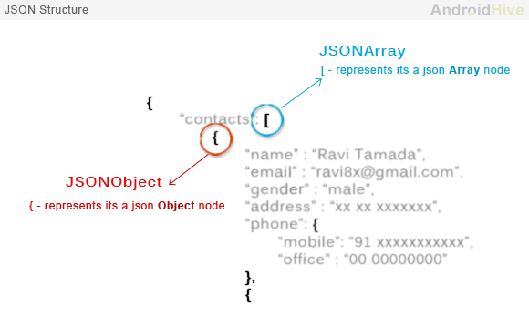

* JSON nodes will start with a square bracket or with a curly bracket.
* The difference between [ and { is, the square bracket ([) represents starting of an **JSONArray** node whereas curly bracket ({) represents**JSONObject**.
* If your JSON node starts with **[**, then we should use **getJSONArray()** method
* If the node starts with**{**, then we should use **getJSONObject()** method.

### JSON Object :

A JSON object contains key/value pairs like map. The keys are strings and the values are the JSON types. Keys and values are separated by comma. The { (curly brace) represents the json object.

|  |
| --- |
| {      "employee": {          "name":       "mangana",          "salary":      100000,          "married":    **true**      }  } |

### JSON Array :

The [ (square bracket) represents the json array.

|  |
| --- |
| { "Employee" :      [       {"id":"101","name":"Sonoo Jaiswal","salary":"50000"},       {"id":"102","name":"Vimal Jaiswal","salary":"60000"}     ]  } |

Example of JSON Object and JSON Array :

{

"sys":

{

"country":"GB",

"sunrise":1381107633,

"sunset":1381149604

},

"weather":[

{

"id":711,

"main":"Smoke",

"description":"smoke",

"icon":"50n"

}

],

"main":

{

"temp":304.15,

"pressure":1009,

}

}